**Institute of Computer Technology**

**B. Tech. Computer Science and Engineering**

*Sub: ESFP – I*

Course Code: 2CSE102

***Practical – 1***

**Name:Dwij vatsal desai**

**Roll No:BDA-08**

**Branch:BDA**

**Class: B**

**Batch:14**

**[Q-1]**  **Problem Definition:(Part-1)**

                                 Method using a third variable:

Sam decides to implement the method using a third variable. He has two integer variables, x and y, with initial values x = 10 and y = 20. Write a C program to help Sam swap the values of x and y using a third variable, and then display the new values.

**ALGORITHM:**

Step 1:- Start

Step 2:- We are given to variables x and y.

Step 3:- and a 3rd variable z.

Step 4:- use the third variable method .

Step 5:- Printthe exchanged value of x and y variable.

Step 6:- End

**FLOWCHART:**

Initialize variables - Farenheit and Celsius.

Ask value from the user in Farenheit and display.

**Solution:**

                Code:-

#include <stdio.h>

void main()

{

  int x=10;

  int y=20;

  int z;

    printf("the actual value of x and y are:- %d and %d",x,y);

    z=x;

    x=y;

    y=z;

    printf("\n the swapped values of x and y are:- %d and %d",x,y);

}

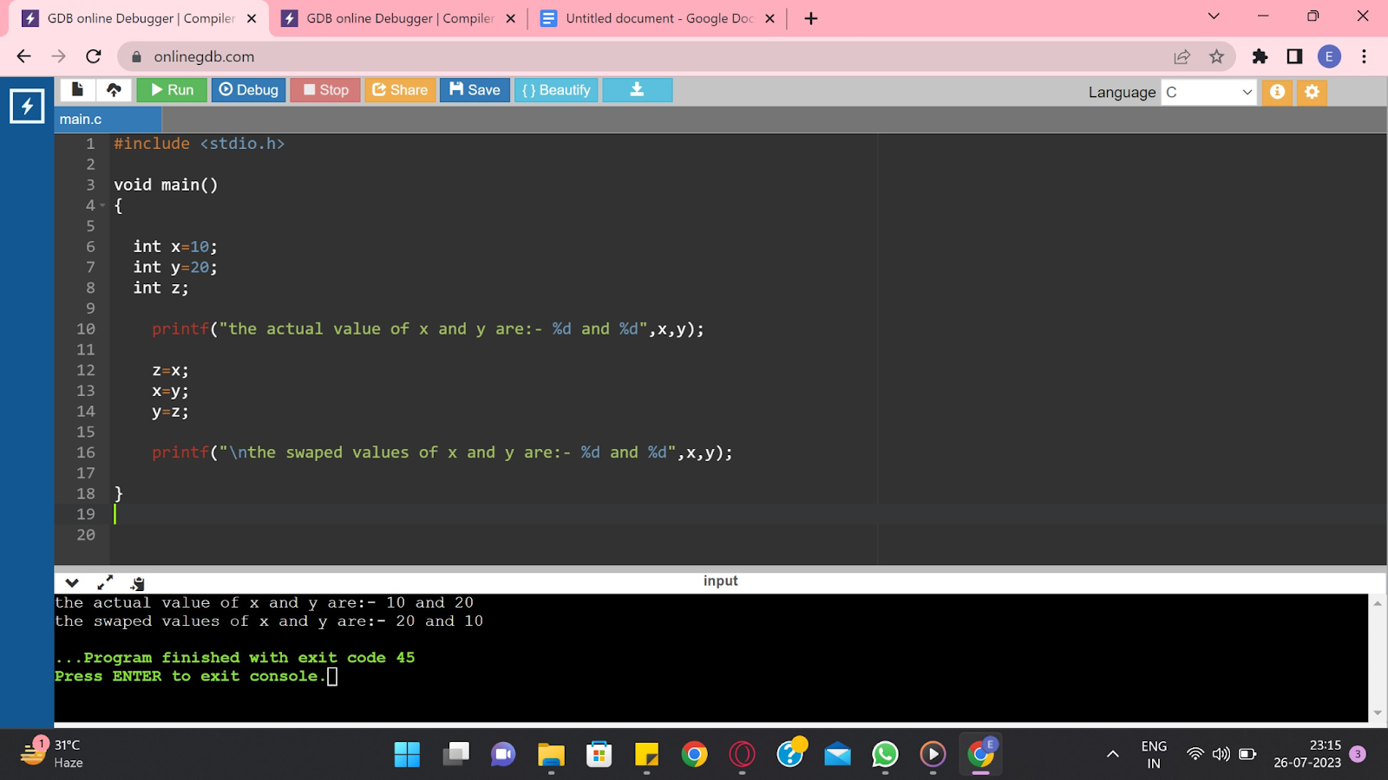

**Problem Definition:(Part-2)**

                                              Method without using a third variable:

Emily prefers an approach that doesn't use an additional variable to swap the values. She also has two integer variables, a and b, with initial values a = 5 and b = 8. Write a C program to assist Emily in swapping the values of a and b without using a third variable, and then display the updated values.

**Solution:**

                Code:-

#include <stdio.h>

void main()

{

   int x=10;

   int y=20;

   printf("the orignal vaule of x and y are:- %d and %d",x,y);

     //useing arthmatic progration.

     x=x+y;

     y=x-y;

     x=x-y;

   printf("\nthe swapped vaule of x and y are:- %d and %d",x,y);

}

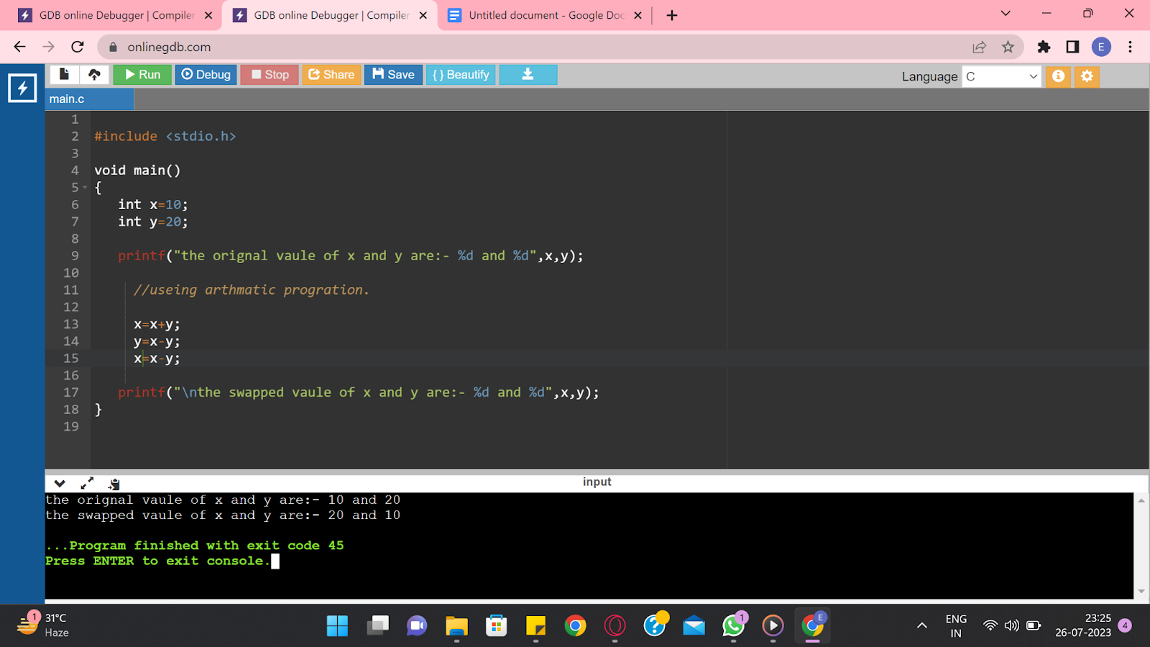

**[Q-2]**  **Problem Definition:(part-1)**

                                            Charlie invests $2000 in a fixed deposit account with a bank that offers a simple interest rate of 4% per annum. Calculate the total amount Charlie will have after 3 years. Assume that the interest is calculated annually.

Simple Interest (SI) = (Principal * Rate * Time) / 100

**Solution:**

                Code:-

#include <stdio.h>

void main()

{

   float p;

   float r;

   float t;

   float total;

   printf("Enter the principal value\t");

   scanf("%f",& p);

   printf("Enter the the percentag rate per anum\t");

   scanf("%f",& r);

   printf("Enter the time of the  fixed deposit\t");

   scanf("%f",&t);

// this is Simple Interest.

   total=(p*r*t)/100;

   printf("Your total amount is equal to %.0f",total+p);

}

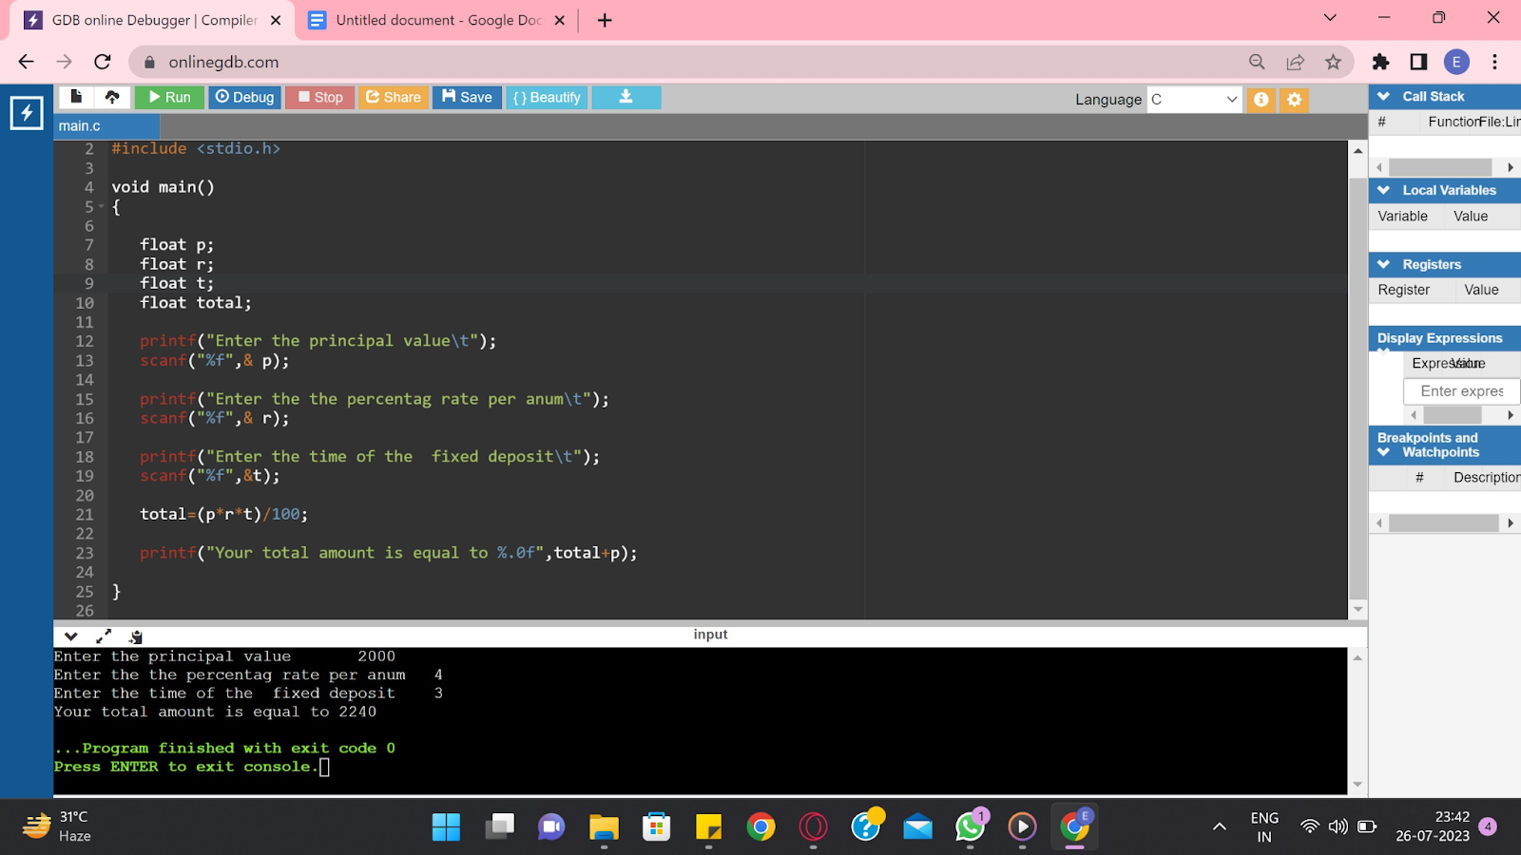

**[Q-2]**  **Problem Definition:(part-2)**

                                                        James invests $1500 in a savings account with a bank that offers a compound interest rate of 5% per annum. Calculate the total amount James will have after 4 years. Assume that the interest is compounded annually.

**Solution:**

                Code:-

#include <stdio.h>

#include <math.h>

void main()

{

   float p;

   float r;

   float t;

   float total;

   printf("Enter the principal value\t");

   scanf("%f",& p);

   printf("Enter the the percentag rate per anum\t");

   scanf("%f",& r);

   printf("Enter the time of the  fixed deposit\t");

   scanf("%f",&t);

// this is Compound Interest.

   total=p*pow(1+r/100,t)-p;

   printf("Your total amount is equal to %.0f",total+p);

}

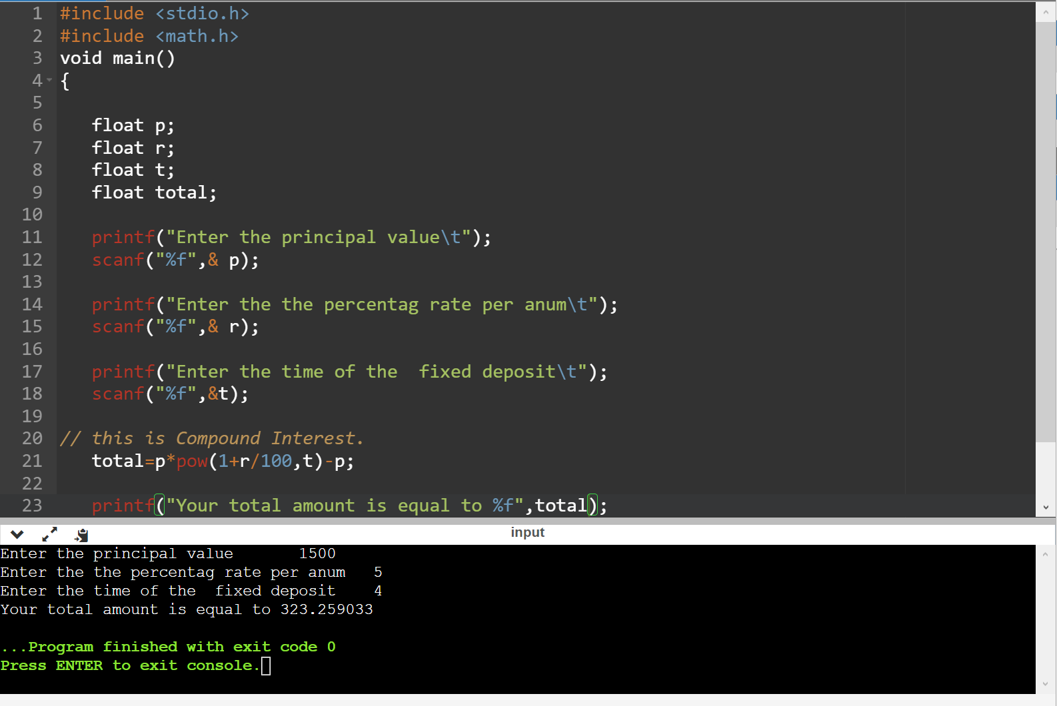

**[Q-3]**  **Problem Definition:**

**[Q-4]**  **Problem Definition:**

                                            You are a student who has just received their 12th-grade mark sheet. The mark sheet contains the marks obtained in five subjects: Physics,Chemistry, Mathematics, English, and Biology. You want to calculate your aggregate marks and percentage to assess your performance in the exams. To do this, you decide to develop a logic to automate the calculation process.

**Solution:**

                Code:-

#include <stdio.h>

void main()

{

   float Physics;

   float Chemistry;

   float Mathematics;

   float English;

   float Biology;

   float total;

   float percentag;

   printf("Physics marks-");

   scanf("%f",& Physics);

   printf("Chemistry marks-");

   scanf("%f",& Chemistry);

   printf("Mathematics marks-");

   scanf("%f",& Mathematics);

   printf("English marks-");

   scanf("%f",& English);

   printf("Biology marks-");

   scanf("%f",& Biology);

   total=Physics+Chemistry+Mathematics+English+Biology;

   printf("Your total is- %f\t",total);

   percentag=(total*100)/500;

    printf("Your percentag is- %f\t",percentag);

}

